- Purpose
  - The purpose of this document is to describe the procedure for load testing a propane machine battery.
- Scope
  - This SOP applies to all equipment assembly team members. The process applies to the following machines:
E012800EQM0600BE1200 – 21” Optima XR
E012805EQM0600BE1200 – 21” Optima XR w/ Clutch
E012815EQM0600BE1200 – 21” Optima XR w/ Emissions & Clutch
E012830EQM0600BE1200 – 27” Optima XR
E012835EQM0600BE1200 – 27” Optima XR w/ Clutch
E012840EQM0600BE1200 – 27” Optima XR w/ Emissions
E012850EQM0600BE1200 – 27” Optima XR w/ Dust Control
E012860EQM0600BE1200 – 27” Optima XR w/ Clutch & Dust Control
E012865EQM0600BE1200 – 27” Optima XR w/ Emissions & Dust Control
E012875EQM0600BE1200 – 27” Optima XR w/ Emissions, Clutch, & Dust Control
E012327EQM0600BE1200 – Big Bertha XSM30 Propane Stripping Machine Pkg
E088398EQM0600BE1200 – Lil Bertha XSM24 Propane Stripping Machine Package
- Responsibilities
  - The operations manager/supervisor is responsible for enforcing this SOP.
- Materials
  - The proper materials needed for this process are listed on the machine work order.
  - Battery Load Tester
- Definitions

- Procedure
  - Take a battery (89827) and clamp the terminals using the appropriate clamps on the load tester.

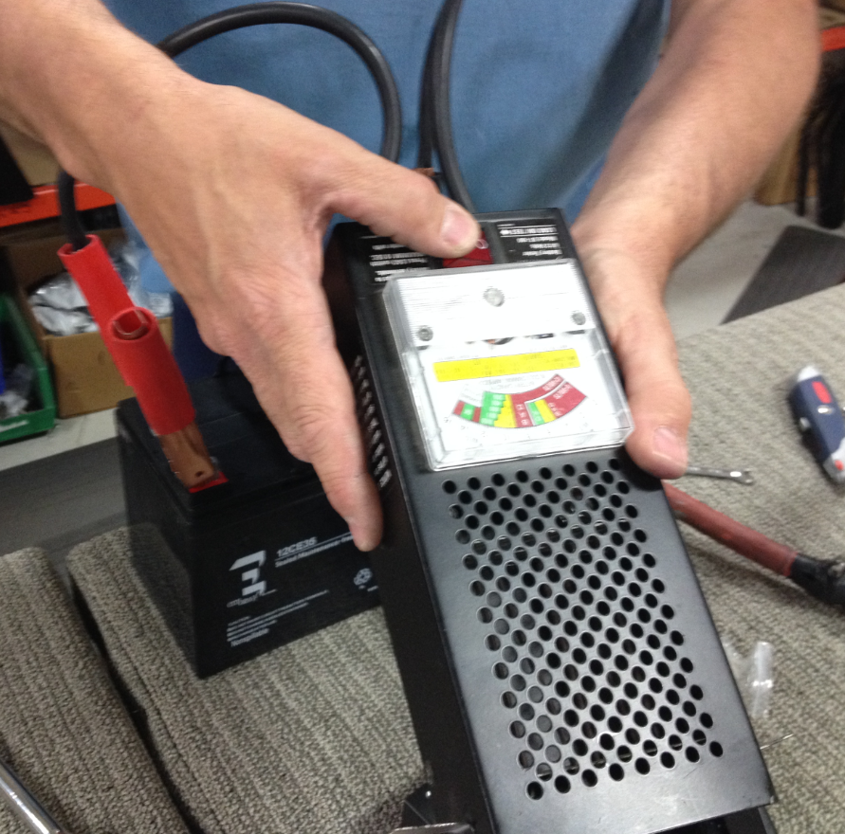
  - Verify that the voltage reading is acceptable. It should read 12V or higher.
  - Press and hold the red button for a couple seconds until the needle stops moving.

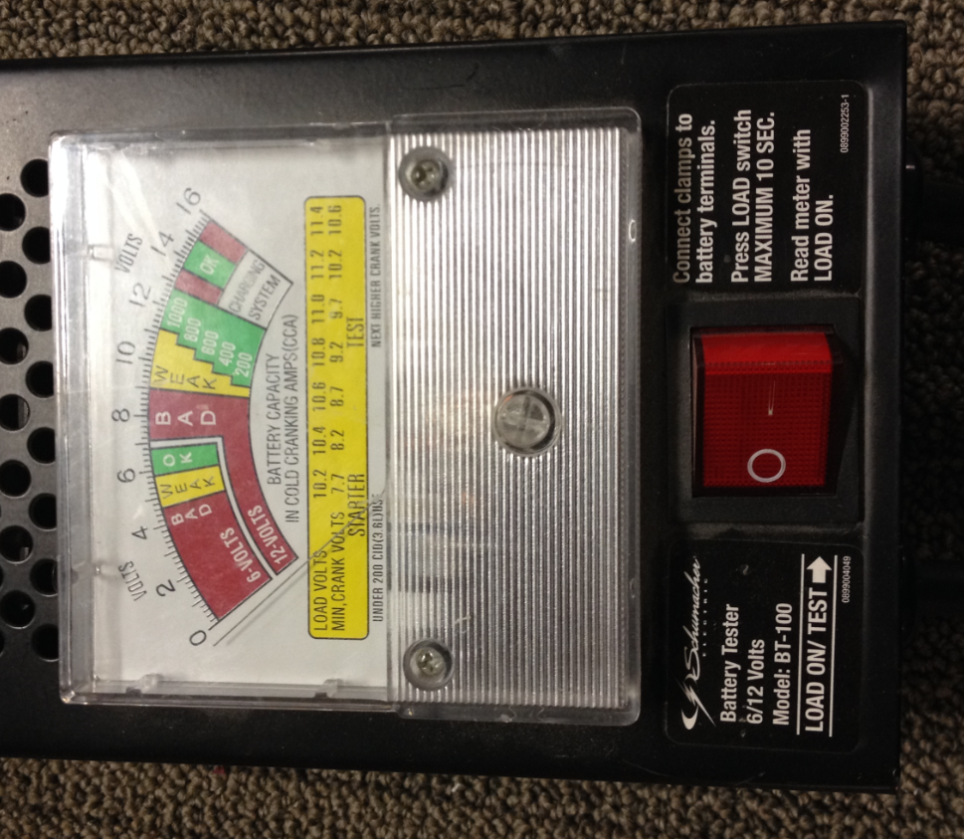

  - Verify that the needle stays in the green area at the 200CCA line.

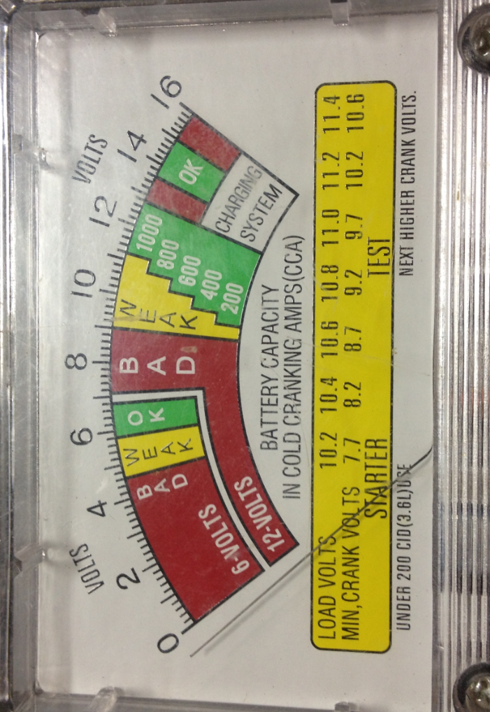
Needle should stay above this line

  - If the battery falls below, it is no good.
- References (optional section as needed)

- Training Guide

Functional Training Groups Requiring Training
Equipment Assembly Group

- SOP Change Control

Date of Change | Reason for Change
Rev 01 - 11/22/2013 | This is the first version of the S.O.P. hence there are no revisions to this document.
Rev 02 - 1/12/2018 | Added responsibilities section
Rev 03 - 5/4/2018 | Updated for the Optima XR upgrades
Rev 04 - 3/21/2025 | Removed work center notes and updated machine ID list in Scope 2.01

Approvals

Submitter/Author Approval:__________________________________ Date:______________________

Management Approval:______________________________________ Date:______________________

QAU Approval:_____________________________________________ Date:______________________

